

**Pimpri Chinchwad Education Trust’s**

**Pimpri Chinchwad College of Engineering, Pune.**

**Department of Applied Science and Humanities,**

**Course: Discrete Mathematics**

**An application of Dijkstra’s Algorithm to shortest route problem.**

**Presented By: -**

**1.Shyam Sundar Yadav [123B1B267]**

**2. Ranveer Deshmukh[123B1B243]**

**3.Parth Sunklod [123B1B274]**

**Guided By:-**

**Ms.Angha chaudhari**

**Abstract:**

Network analysis is an essential tool used in transport sector, information sector and also for the flow of matter and energy. Thus, choosing efficient route is essential for businesses and industries which aid distribution of goods and services optimally. This research addresses the problem of Asian Paints PVT Ltd in transporting their products from their production plant to stores of sales by presenting analysis of the shortest path using Dijkstra’s Algorithm and it was concluded that the best paths found from the analysis will save the company less distance in transporting the paints and minimize time and cost of fueling their vehicles.

The analysis shows that the best route which provides the shortest distance will be from node 1 – 3 – 5 – 8 (Pune – Shivajinagar – Location – Akurdi), when transporting from Pune (the production location) to Akurdi the company’s major.

**Keywords:** Directed Network, node, activity, Dijkstra’s Algorithm,Permissible route,

**Introduction:**

Networks arise in numerous settings and in a variety of ways, ranging from transportation, electrical, and communication networks which pervade our daily lives. Network representations are widely used for problems in diverse areas as oil transportation, production, distribution, project planning, facilities location, resource management, and financial planning, etc. It provides a powerful visual and conceptual aid that is used to portray the relationships between the components of systems in virtually every field of scientific, social, and economic endeavour. One of the most exciting developments in operations research (OR) in recent years has been the unusually rapid advance in both the methodology and application of network optimization models.

The model takes in all aspects of the business, helping management to plan and decide different levels at the various stages in the industry, e.g. knowing what to pay and what to charge.A network representation is essential in an industry because it helps to determine and monitor the flow of goods from the industry to its final destination. Taking the crude oil as an example, network representation can help determine the various stages, from crude oil purchase, shipping to refineries, refining it, to sending it for storage and distribution for sale purposes. Network optimization is a special type of linear programming model. Network models have three main advantages over linear programming.

* 1. **Background of Study.**

Networks are necessary for the movement of people, transportation of goods, communicate information and control of the flow of matter and energy. Network application is quite vast. Phenomena that are represented and analyzed as networks are roads, railways, cables, and pipelines. In networking, the cost, time, and complex nature of network increases in different kinds of network-based systems, e.g. Television cable networks, Telephone networks, Electricity supply networks, Gas pipe network and water supply system. Therefore, the cost, time, and complexity of network are considered greatly in solving networking problems. A graph is a mathematical abstraction that is useful for solving different networking problems. Finding the shortest paths plays an important role in solving network based systems. In graph theory, a number of algorithms can be applied for finding the shortest path in a graph based network system. This reduces the complexity of the network path, the cost, and the time to build and maintain the network based systems.

Networks are used in general to represent shortest path problem. A graph which is used to solve such problems contains sets of vertices and edges. Pairs of vertices are connected by edges, while movement from one vertex to other vertices can be done along the edges. A graph can be directed or undirected depending on the movement along the edges, either walking on both sides or on only one side. Lengths of edges are often called weights which are normally used to calculate the shortest path from a particular point to another point. In the real world, the graph theory can be applied to different scenarios. A practical example is map representation using a graph, where vertices and edges represent cities and routes that connect the cities respectively. One-way routes are directed graphs, while routes that are not one-way are undirected. There are different types of algorithms that are used to solve shortest path problems. However, only the Dijkstra’s algorithm will be discussed in this project.

* 1. **Aim and Objectives of Study**

The aim of this project is to determine the shortest route from the production plant of a local paint company (Asian Paints Private limited) to 7 different dealers in the state with a permissible route.

**The Shortest Route Problem**

This particular problem determines the route of minimum weight that connects two vertices namely a source and a destination in a weighted graph in a transportation network. Other situation can be represented by the same model like the Very Large Scale Integrated (VLSI) design, equipment replacement, and others. Different types of shortest path algorithm are used to determine the shortest path of a graph. The most frequently encountered path are the shortest path between two specified vertices, the shortest path between all pairs of vertices, and the shortest path from a specified vertex to all others. The Dijkstra’s algorithm is the most efficient algorithm used to find the shortest path between a known vertex to other vertices. Some improvements on Dijkstra’s algorithm are done in terms of efficient implementation and cost matrix. In this project, we propose to implement the Dijkstra’s algorithm to determine the shortest route from the production plant of the company to any of the other location in the network.

**Principle of Dijkstra’s Algorithm**

To find the shortest path between two given vertices of a graph, we will follow the following mentioned steps of the algorithm/approach, which are:

if dist(u) + len(u,v) < dist(v)

   dist(v) = dist(u) + len(u,v)

Where,

dist(u) = Source Node

dist(v) = Destination Node

Note: By default, the source node's immediate and non-immediate distance to the other nodes in the graph is “∞ (Infinite).”

**IV. Analysis of Data**

This section introduces the data and analytical approach of the methodology used in the project research. The locations used for this project work was obtained from Asian Paints Pvt. Ltd. and also the distance in kilometre (km) between each location in the graph was measured using Google maps location.

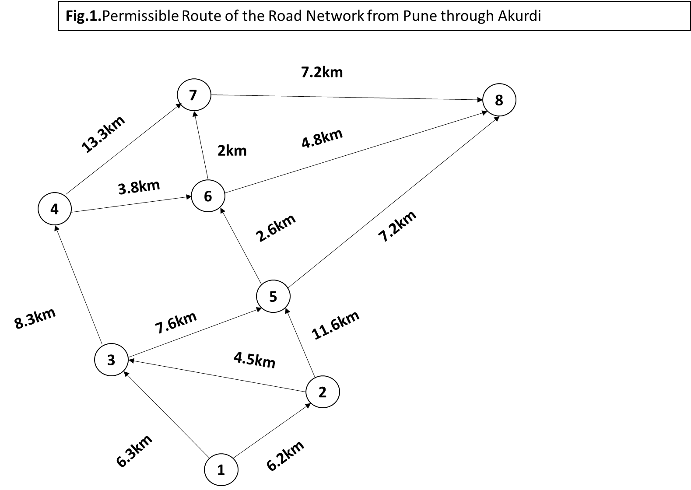

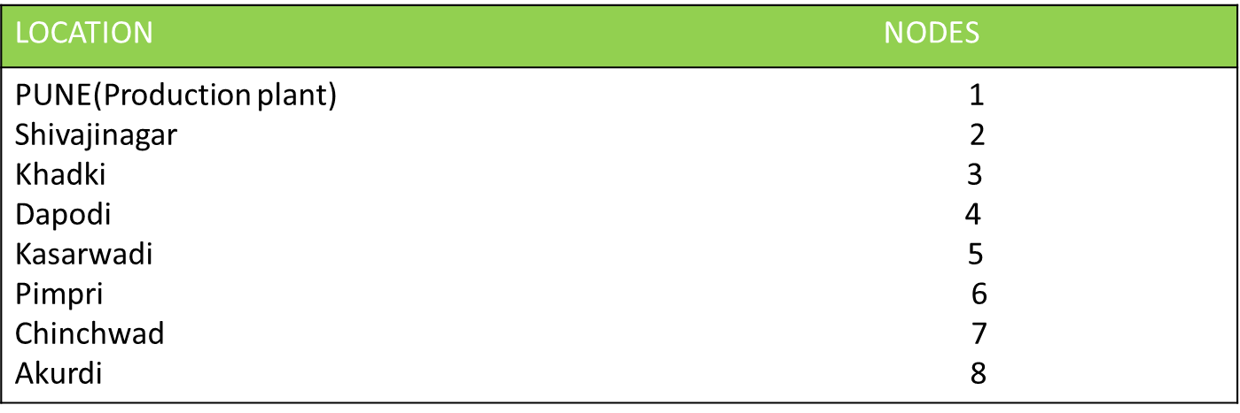

Table 4.0. Names of location and Nodes identification

**4.1 Analytical Solution to the Problem.**

Iteration 0: Assign the permanent label [0, ∞].

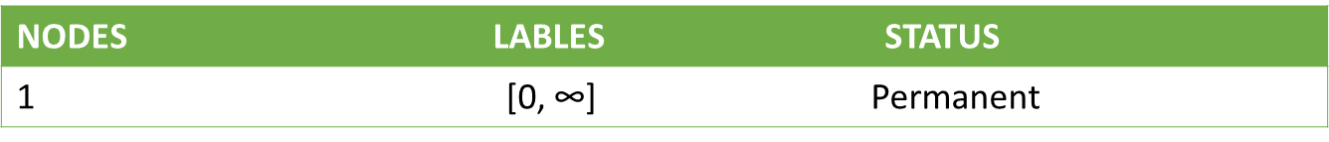

**Table 1**

1: Node 2 and node 3 can be reached from (the last permanent labelled) node 1, thus the list of labelled nodes becomes (temporary and permanent).

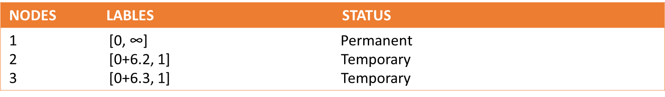

**Table 2**

For the two temporary labels [6.2, 1] and [6.3, 1], node 2 yields the smaller distance (u2 = 6.2). Thus the status of node 2 is changed to permanent.

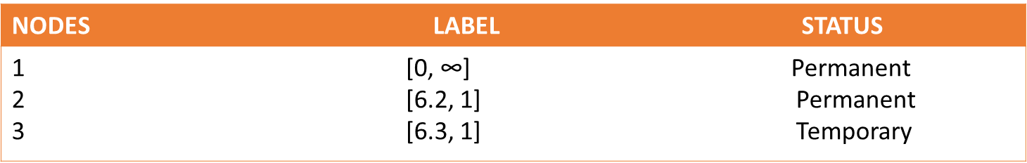

**Table 3a**

**Iteration 2:**

The new starting node is node 2. Node 3 and node 5 can be reached from node 2. Thus the list of labelled nodes becomes:

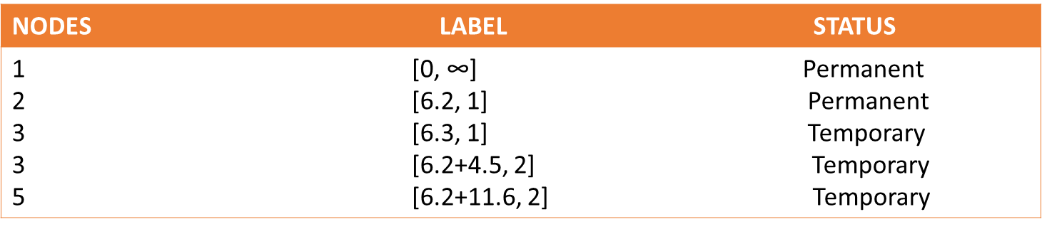

**Table 3b**

Node 3 temporary label [6.3, 1] obtained in iteration 1 remains the same because in iteration 2 node 3 holds another label [10.7, 2] and the shorter distance found is that of label [6.3, 1].

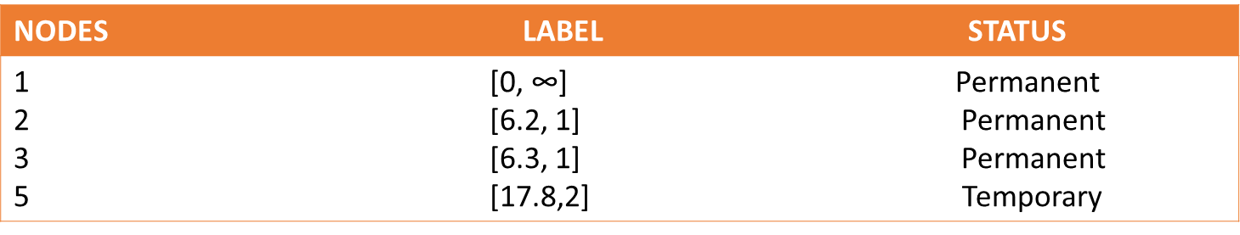

**Table 4**

Node 3 yields the shorter distance (u3 = 6.3), thus the status of node 3 changed to permanent.

Iteration 3: Node 3 becomes the new start point. Node 3 connects to node 4 and node 5. Thus the list of labelled nodes is updated as:

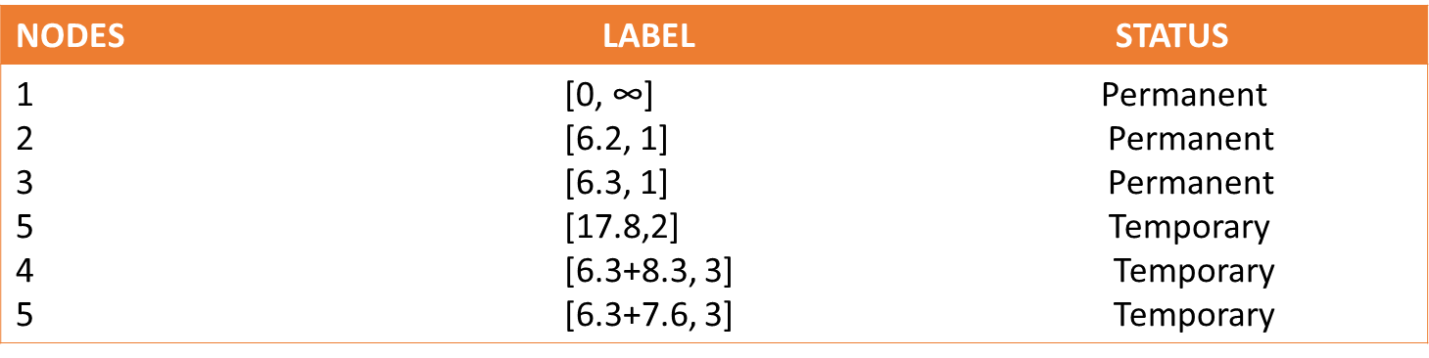

**Table 5**

Node 5 temporary label [17.8, 2] obtained from iteration 2, is thus changed to [13.9, 3] obtained in iteration 3 to indicate a shorter route through node 3. Thus the shorter distance is node 5 (u5 = 13.9) labelled [13.9, 3], thus we change the status of node 5 permanent. The list of labelled node now becomes;

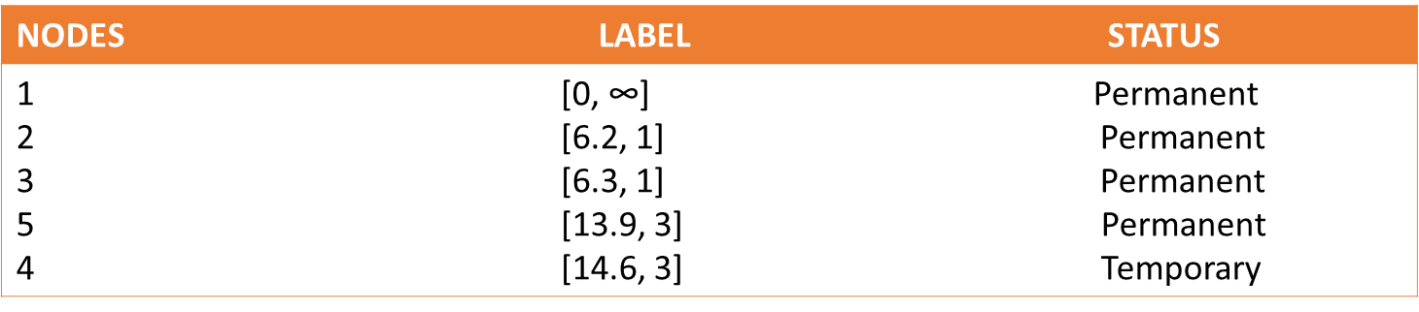

**Table 6**

Iteration 4: Node 6 and node 8 can be reached from node 5. The list of labelled nodes thus becomes:

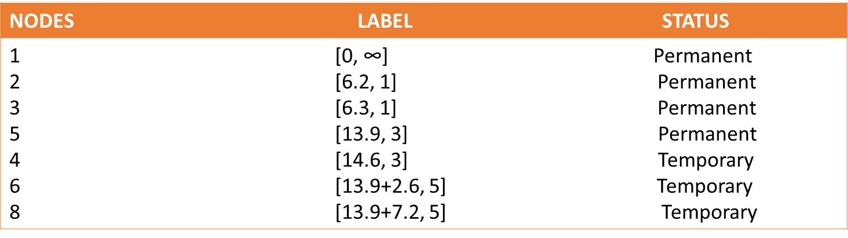

**Table 7**

Node 6 yields the shorter distance from node 5, thus the status of node 6 (u6 = 16.5) becomes permanent. The list is now updated to become;

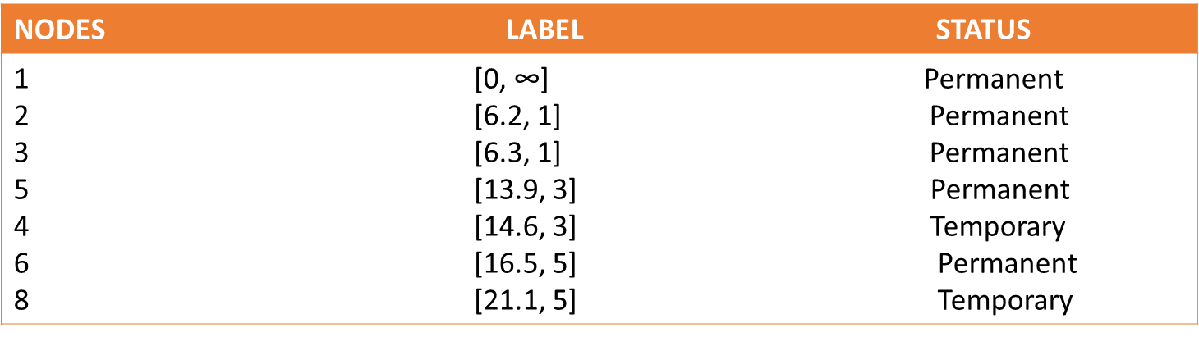

**Table 8**

Iteration 5: From node 6, node 7 and node 8 can be reached

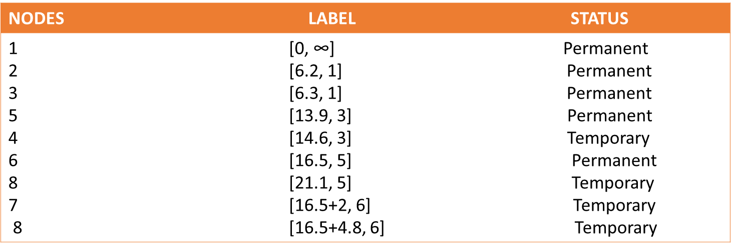

**Table 9**

Node 8 temporary label [21.3, 6] obtained from iteration 5, is thus changed to [21.1, 5] obtained in iteration 4 to indicate a shorter route through node 5. Thus the shorter distance is node 7 (u7 = 18.5) labelled [18.5, 6], thus we change the status of node 7 permanent. The list of labelled nodes now becomes;

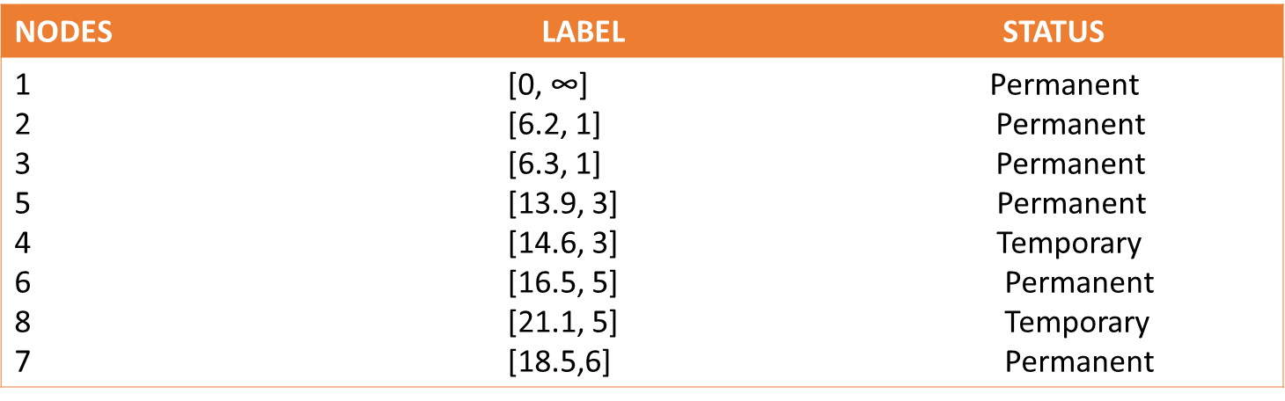

**Table 10**

Node 8 can be reached only from node 7

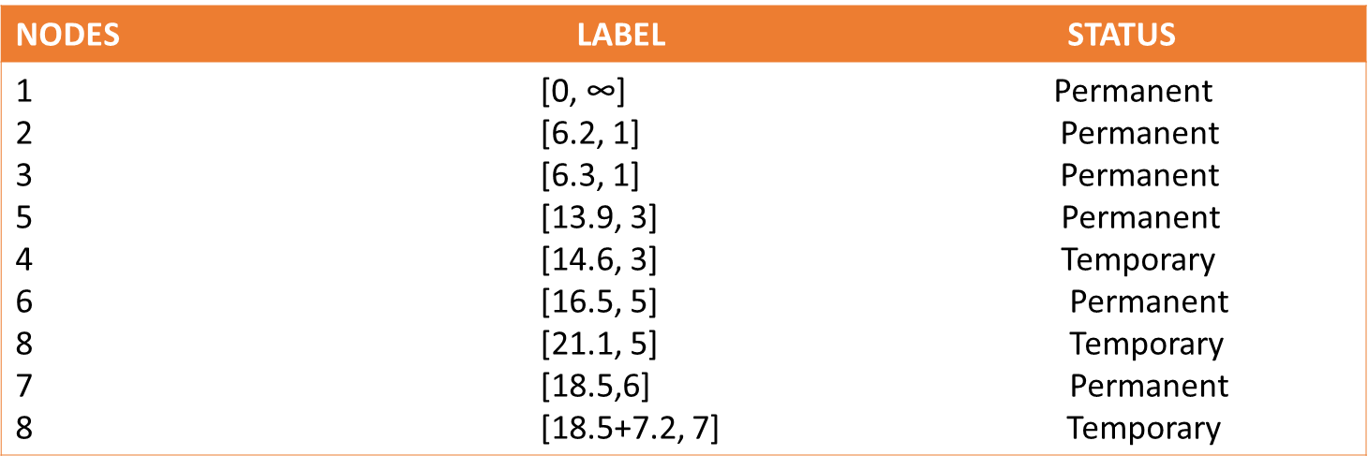

**Table 11**

Node 8 temporary label [25.7, 7] obtained from iteration 6, is changed to [21.1, 5] obtained in iteration 5 to indicate a shorter route has been found through node 5. Thus we change the status of node 8 (u8 = 21.1) permanent. The list of labelled node now becomes;

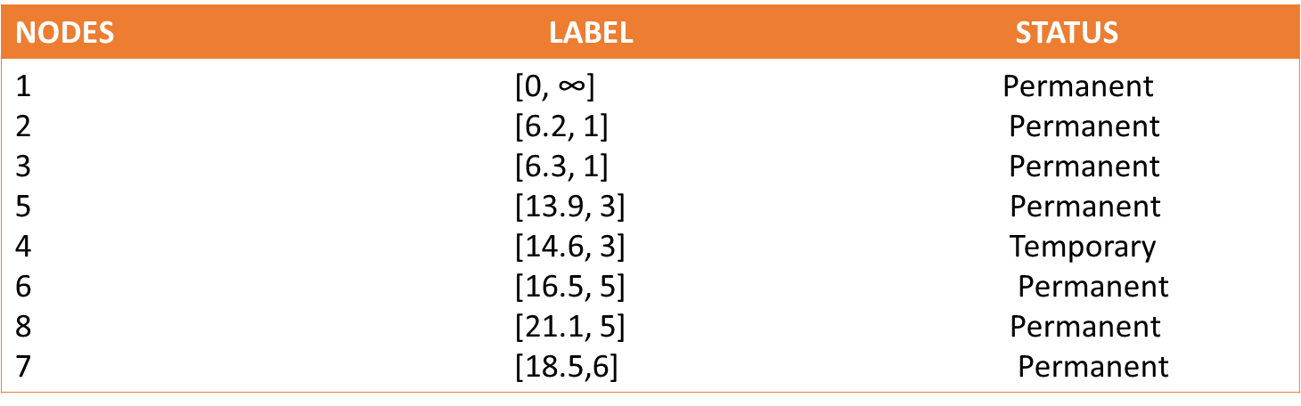

**Table 12**

**Iteration 7:**Again node 7 can be reached from node 4.The list of labelled nodes:

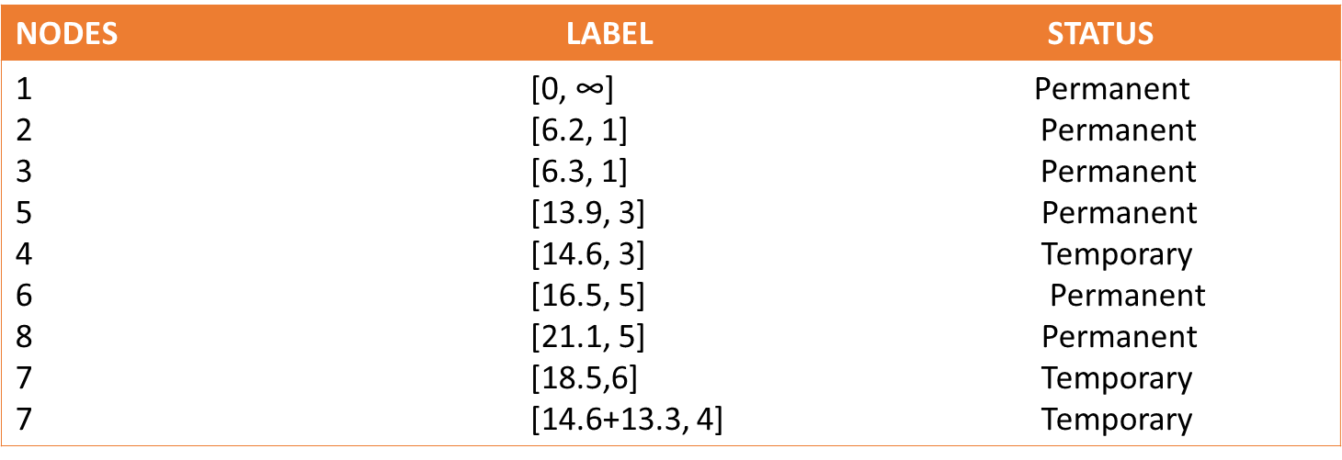

**Table 13**

Node 7 temporary holds label [27.9, 4] obtained from iteration 7, is thus changed to [18.5, 6] obtained in iteration 6 to indicate a shorter route has be found through node 4. Therefore node 7 is updated as (u7 = 18.5) labelled [18.5, 6], we cannot change the status of node 7 since it is already permanent. The list of labelled node now becomes;

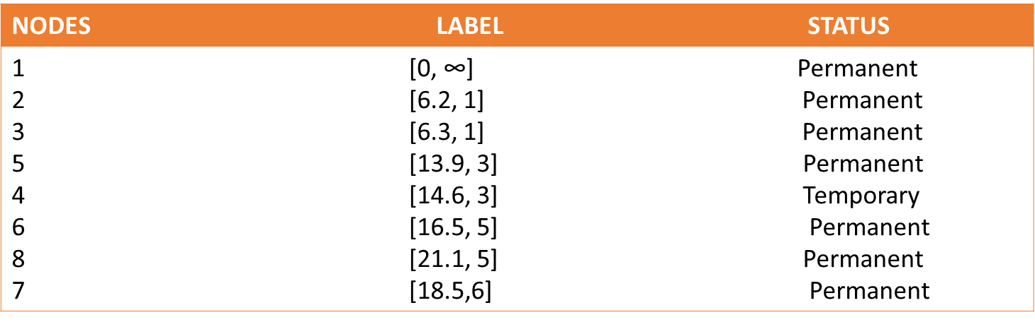

**Table 14**

**Iteration 8**

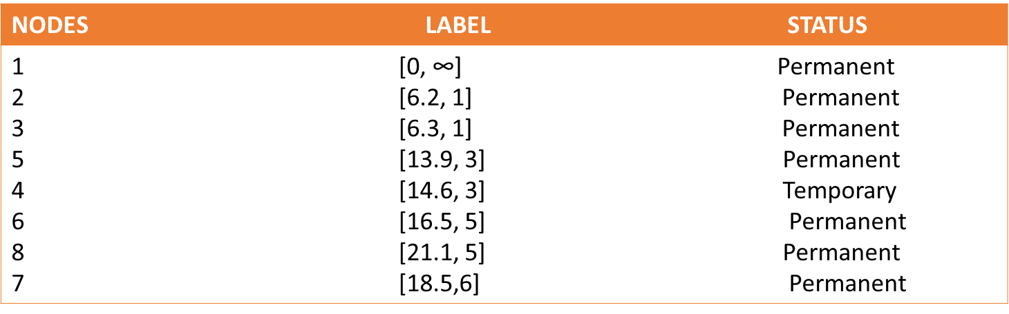

**Table 15**

Since node 4 can only be accessed by node 3 therefore we make node 4 (u4 = 14.6) status permanent

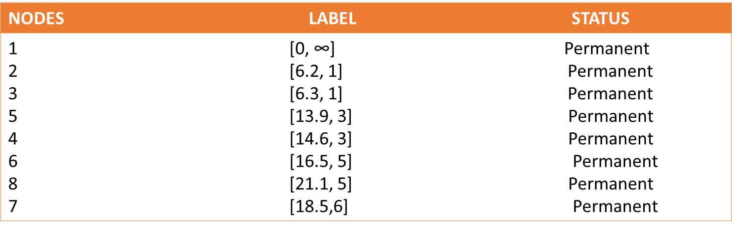

**Table 16**

Now all nodes in the list have attained its status as permanent, we can therefore say we have obtained the maximum iteration for the problem. Therefore the solution to the shortest route and distance from node 1 to any other node in the network is thus;

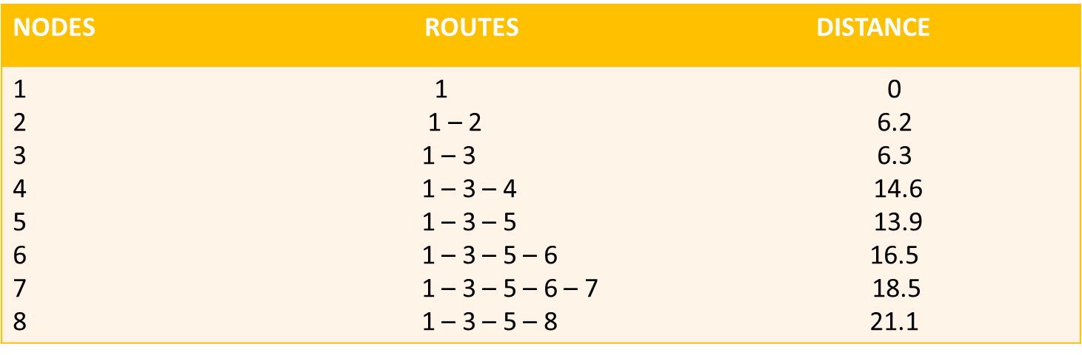

**Table 17**

**V. Conclusion**

The shortest route between node 1 (production plant) and any other node in the network can be determined by starting at the desired destination and back-tracking through the nodes using the information given by the permanent labels (Table.4.1.16), for example the sequence or route determines the shortest route from node 1 to node 7. (7) – [18.5, 6] – (6) – [16.5, 5] – (5) – [13.9, 3] – (3) – [6.3, 1] – (1) Thus the desired route is; 1 – 3 – 5 – 6 – 7

**Summary**

In this paper,we discussed the problem of finding the shortest route motivated by the need to minimize the distance and time of transporting goods from the company’s production plant to seven different dealers in the road network given by the data. The application of the Shortest Path using Dijkstra’s Algorithm tackled the problem effectively. The results from the analysis of the data show that the company can implement the use of Dijkstra’s Algorithm to obtain the shortest route to transport their products from Aluu to another destination of choice.

**VI. Recommendation**

Based on the conclusion of the project research work, we recommend that the company implements the Dijkstra’s Algorithm to find the shortest routes from their current production plant to any delivery store of choice now and in the nearest future to help them;

· Minimize the distance of transporting the goods.

· Save time in transporting the products profit of the company.

· Minimize the cost of running the transportation of goods to maximize profits of the company.

**Reference**

[1]. Ahmat, K. A. (n.d.). Graph Theory and Optimization Problems for Very Large Networks. New York: City University of New

York/Information Technology.

[2]. Brendan, H. a. (2005). Generalizing Dijkstra's Algorithm and Gaussian Elimination for solving MDPs. International Conference on

Automated Planning and Scheduling/Artificial Intelligence Planning System, (pp. 151 - 160).

[3]. Chen, K. M. (2009). A real-time wireless route guidance system for urban traffic management and its performance evaluation.

Papers of the 70th Vehicular Technology Conference Anchorage VTC, (pp. 1 -5).

[4]. Ebrahimnejad, S. A. (2011). Find the Shortest Path in Dynamic Network using Labelling Algorithm. Journal of Business and Social

Science.

[5]. Goldberg, A. V. (n.d.). Point - to - Point Shortest Path Algorithms with Pre-processing. Silicon Valley:MicrosoftResearch.

[6]. Goyal, S. (n.d.). A Survey on Travelling Salesman Problem. North Dakota: Department of Computer, University of North Dakota.

[7]. Lee, D. C. (2006). Proof of a modified Dijkstra's algorithm for computing shortest bundle delay in networks with deterministically

time-varying links. IEEE Communications Letters, 734 -736.

[8]. Lieberman, F. S. (2001). Introduction to Operations research seventh edition. Mc Graw Hill.

[9]. Lili Cao, X. Z. (n.d.). Approximating Shortest Path in Social Graph. U.C. Santa Barbara: Computer Science Department.

[10]. Meghanathan, D. N. (n.d.). Review of Graph Theory Algorithms . MS: Department of Computer Science , Jackson State University.

[11]. Nar, D. (1997). Graph theory with applications to engineering and computer science. Prenctice Hall.

[12]. Sadavare, A. (2012). International Journal of Computer Science and Information Technologies, 5296 - 5300.

[13]. Scutella, S. P. (1997). Technical report on Shortest Path Algorithms in Transportation models, Classical and innovative aspects.